Myron Doc Downing PhD
Author | Therapist | Seminar Leader | BA, MSW, PhD

MAKING PEACE WITH ANGER
Your Own and Others Too

Most people find that they are not capable of making peace with anger.
There are two problems when it comes to reconciling anger and peace.
First, You cannot make peace with anger unless you are able to recognize anger in yourself and others too.
Second, you cannot make peace with anger if you are afraid of anger in yourself and others too.
Let us start with recognizing anger in yourself. But, you say, “I never get angry, I just get upset.” Anger comes in degrees, starting with just a little bit of anger which most people call annoyed, irritated, and so on up to you get to hate and rage.
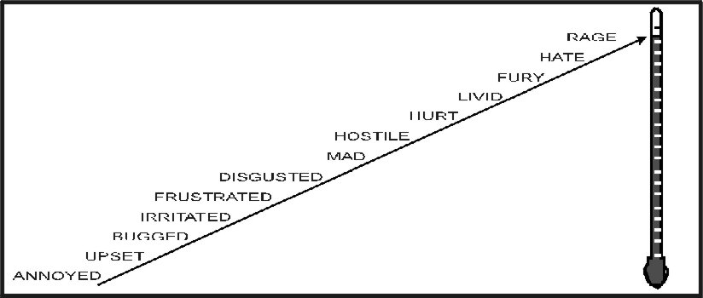
All people feel, all feelings. Birds fly, fish swim, and people feel. It is possible to repress your feelings to the point that you are no longer aware of some’s specific feeling. When this is done then that feeling will be manifest in some other form.
To reclaim feelings that have been repress, such as anger, you will need to confront your false beliefs around anger. Here are some of the irrational and false beliefs that many people hold:
- Emotional Pain Is Terminal, “I can never stand to be hurt that way again.” If you have ever been hurt so emotionally that you hurt physically then you know that this is a false statement, because you experience that pain and are still alive. That pain proved only one thing, what a gutsy, strong person you are! If you went through it once you could, if you need to, go through it again.
- Anger is both physically and emotionally hurtful to yourself and to others. Not true! No one has ever gone to jail for being angry. It is how you express your anger that can put you in jail. It is not what you say it is how you say it. In EQ you can learn how to be yelling, screaming angry in ways that strengthen your relationship with yourself and with others.
- “He who raises his voice first, loses.” The concept of “losing face” is another misguided, and false concept. Raising your voice, does not mean you are out of control. Passionate people raise their voices all the time. Probably, a better concept would be “He who loses control first, loses.” You can be out of control without raising your voice. You can raise your voice and be in complete control.
Are you willing to recognize and accept your anger? Are you able to recognize and accept anger in other people? If you are then you are well on your way to making peace with anger.
There are no good feelings or bad feelings. It is what you do with your feelings that can bring peace or conflict to your life. Mahatma Gandhi was a truly angry man. He hated the British being in India. Nelson Mandela used his anger to destroy apartheid in South Africa. Martin Luther King used his anger to lead the fight against segregation in America.
Feelings are not good or bad! They just are.
Using your anger and hate to change the world towards peace is part of the goal of EQ.

